Yoshinori Ohsumi Wins Nobel Prize in Physiology or Medicine for Cellular Breakdown, Recycling Discoveries
Mon, 10/03/2016 - 8:26amby The Nobel Assembly at Karolinska Institutet
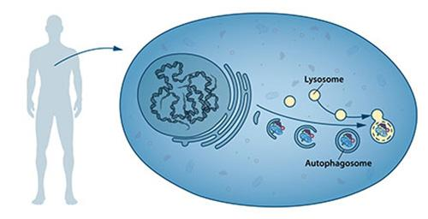
Figure 1: Our cells have different specialized compartments. Lysosomes constitute one such compartment and contain enzymes for digestion of cellular contents. A new type of vesicle called autophagosome was observed within the cell. As the autophagosome forms, it engulfs cellular contents, such as damaged proteins and organelles. Finally, it fuses with the lysosome, where the contents are degraded into smaller constituents. This process provides the cell with nutrients and building blocks for renewal.

This year's Nobel Laureate discovered and elucidated mechanisms underlying autophagy, a fundamental process for degrading and recycling cellular components.
The word autophagy originates from the Greek words auto-, meaning "self", and phagein, meaning "to eat". Thus,autophagy denotes "self eating". This concept emerged during the 1960's, when researchers first observed that the cell could destroy its own contents by enclosing it in membranes, forming sack-like vesicles that were transported to a recycling compartment, called the lysosome, for degradation. Difficulties in studying the phenomenon meant that little was known until, in a series of brilliant experiments in the early 1990's, Yoshinori Ohsumi used baker's yeast to identify genes essential for autophagy. He then went on to elucidate the underlying mechanisms for autophagy in yeast and showed that similar sophisticated machinery is used in our cells.
Ohsumi's discoveries led to a new paradigm in our understanding of how the cell recycles its content. His discoveries opened the path to understanding the fundamental importance of autophagy in many physiological processes, such as in the adaptation to starvation or response to infection. Mutations in autophagy genes can cause disease, and the autophagic process is involved in several conditions including cancer and neurological disease.
Degradation – a central function in all living cells
In the mid 1950's scientists observed a new specialized cellular compartment, called an organelle, containing enzymes that digest proteins, carbohydrates and lipids. This specialized compartment is referred to as a "lysosome" and functions as a workstation for degradation of cellular constituents. The Belgian scientist Christian de Duve was awarded the Nobel Prize in Physiology or Medicine in 1974 for the discovery of the lysosome. New observations during the 1960's showed that large amounts of cellular content, and even whole organelles, could sometimes be found inside lysosomes. The cell therefore appeared to have a strategy for delivering large cargo to the lysosome. Further biochemical and microscopic analysis revealed a new type of vesicle transporting cellular cargo to the lysosome for degradation (Figure 1). Christian de Duve, the scientist behind the discovery of the lysosome, coined the term autophagy, "self-eating", to describe this process. The new vesicles were named autophagosomes.
During the 1970's and 1980's researchers focused on elucidating another system used to degrade proteins, namely the "proteasome". Within this research field Aaron Ciechanover, Avram Hershko and Irwin Rose were awarded the 2004 Nobel Prize in Chemistry for "the discovery of ubiquitin-mediated protein degradation". The proteasome efficiently degrades proteins one-by-one, but this mechanism did not explain how the cell got rid of larger protein complexes and worn-out organelles. Could the process of autophagy be the answer and, if so, what were the mechanisms?
A groundbreaking experiment
Yoshinori Ohsumi had been active in various research areas, but upon starting his own lab in 1988, he focused his efforts on protein degradation in the vacuole, an organelle that corresponds to the lysosome in human cells. Yeast cells are relatively easy to study and consequently they are often used as a model for human cells. They are particularly useful for the identification of genes that are important in complex cellular pathways. But Ohsumi faced a major challenge; yeast cells are small and their inner structures are not easily distinguished under the microscope and thus he was uncertain whether autophagy even existed in this organism. Ohsumi reasoned that if he could disrupt the degradation process in the vacuole while the process of autophagy was active, then autophagosomes should accumulate within the vacuole and become visible under the microscope. He therefore cultured mutated yeast lacking vacuolar degradation enzymes and simultaneously stimulated autophagy by starving the cells. The results were striking! Within hours, the vacuoles were filled with small vesicles that had not been degraded (Figure 2). The vesicles were autophagosomes and Ohsumi's experiment proved that authophagy exists in yeast cells. But even more importantly, he now had a method to identify and characterize key genes involved this process. This was a major break-through and Ohsumi published the results in 1992.
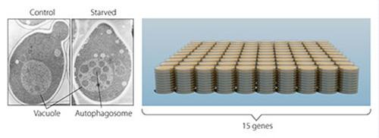
Figure 2: In yeast (left panel) a large compartment called the vacuole corresponds to the lysosome in mammalian cells. Ohsumi generated yeast lacking vacuolar degradation enzymes. When these yeast cells were starved, autophagosomes rapidly accumulated in the vacuole (middle panel). His experiment demonstrated that autophagy exists in yeast. As a next step, Ohsumi studied thousands of yeast mutants (right panel) and identified 15 genes that are essential for autophagy.

Autophagy genes are discovered
Ohsumi now took advantage of his engineered yeast strains in which autophagosomes accumulated during starvation. This accumulation should not occur if genes important for autophagy were inactivated. Ohsumi exposed the yeast cells to a chemical that randomly introduced mutations in many genes, and then he induced autophagy. His strategy worked! Within a year of his discovery of autophagy in yeast, Ohsumi had identified the first genes essential for autophagy. In his subsequent series of elegant studies, the proteins encoded by these genes were functionally characterized. The results showed that autophagy is controlled by a cascade of proteins and protein complexes, each regulating a distinct stage of autophagosome initiation and formation (Figure 3).
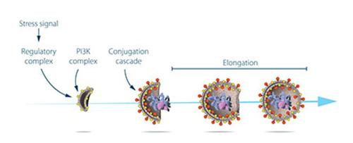
Figure 3: Ohsumi studied the function of the proteins encoded by key autophagy genes. He delineated how stress signals initiate autophagy and the mechanism by which proteins and protein complexes promote distinct stages of autophagosome formation.

Autophagy – an essential mechanism in our cells
After the identification of the machinery for autophagy in yeast, a key question remained. Was there a corresponding mechanism to control this process in other organisms? Soon it became clear that virtually identical mechanisms operate in our own cells. The research tools required to investigate the importance of autophagy in humans were now available.
Thanks to Ohsumi and others following in his footsteps, we now know that autophagy controls important physiological functions where cellular components need to be degraded and recycled. Autophagy can rapidly provide fuel for energy and building blocks for renewal of cellular components, and is therefore essential for the cellular response to starvation and other types of stress. After infection, autophagy can eliminate invading intracellular bacteria and viruses. Autophagy contributes to embryo development and cell differentiation. Cells also use autophagy to eliminate damaged proteins and organelles, a quality control mechanism that is critical for counteracting the negative consequences of aging.
Disrupted autophagy has been linked to Parkinson's disease, type 2 diabetes and other disorders that appear in the elderly. Mutations in autophagy genes can cause genetic disease. Disturbances in the autophagic machinery have also been linked to cancer. Intense research is now ongoing to develop drugs that can target autophagy in various diseases.
Autophagy has been known for over 50 years but its fundamental importance in physiology and medicine was only recognized after Yoshinori Ohsumi's paradigm-shifting research in the 1990's. For his discoveries, he is awarded this year's Nobel Prize in physiology or medicine.

